##Bootstrap Example

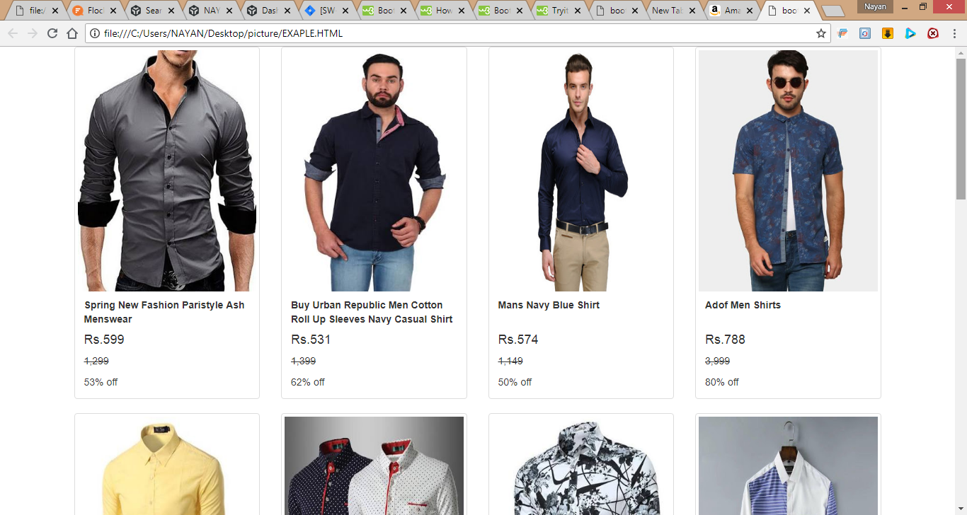

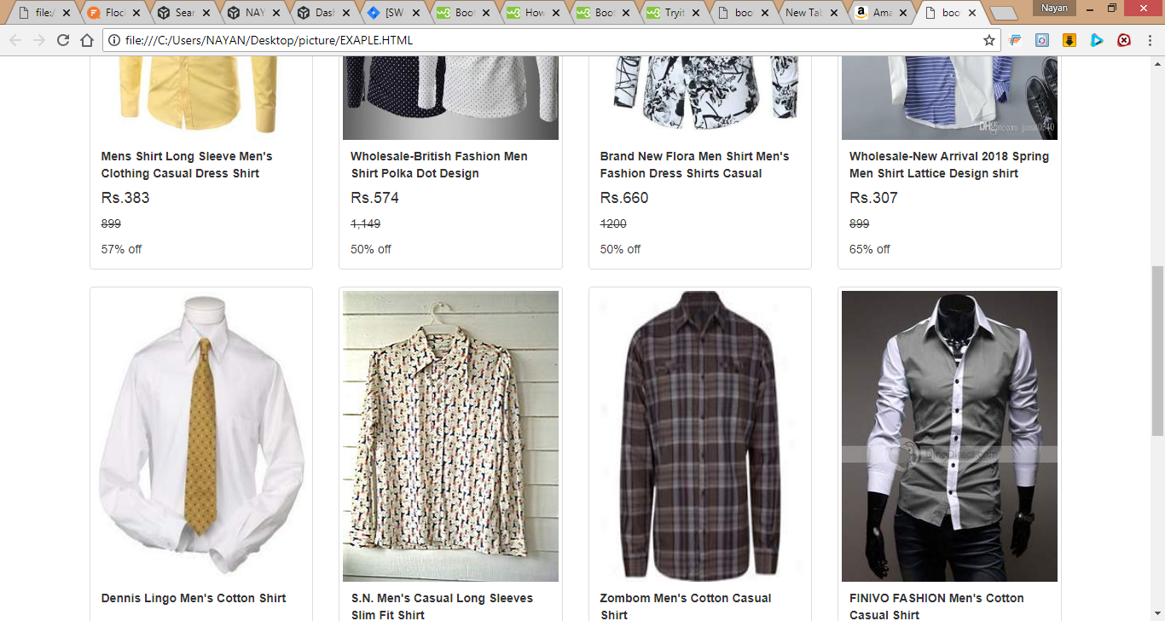

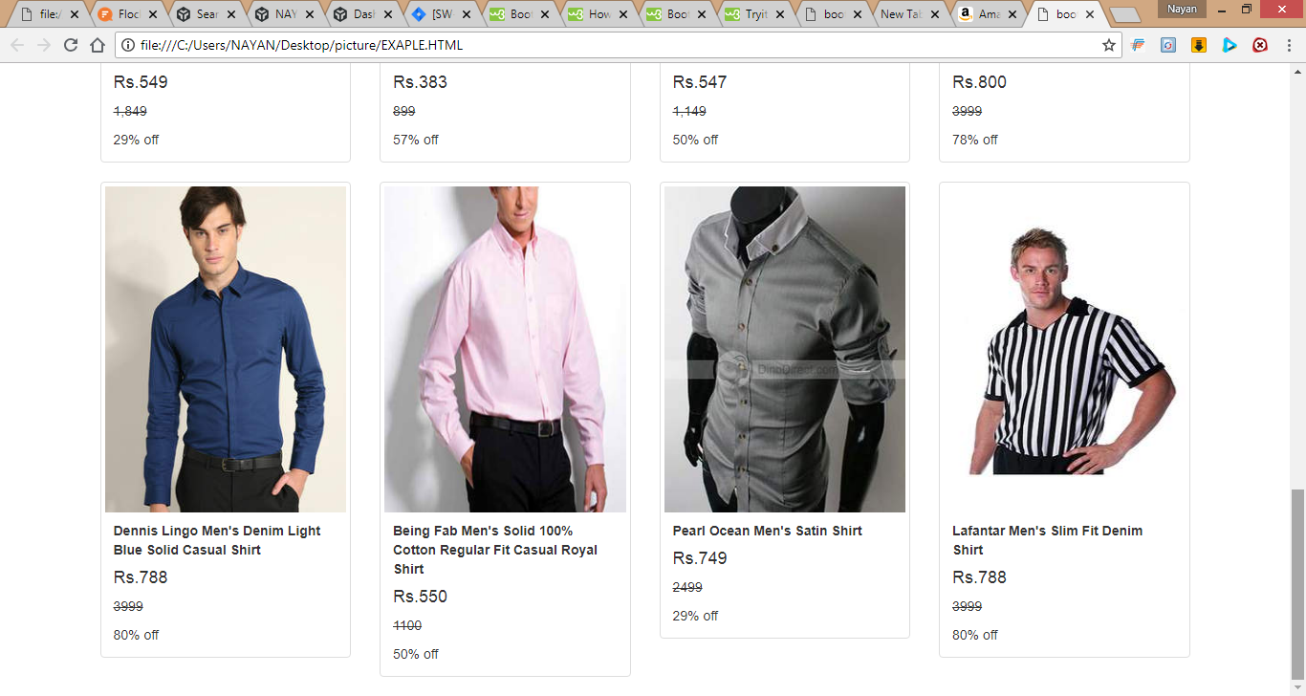

<!DOCTYPE html>

<html>

<head>

<title>bootstrap example</title>

<meta charset="utf-8">

<meta name="viewport" content="width=device-width" inital-scale="1">

<link rel="stylesheet" type="text/css" href="https://maxcdn.bootstrapcdn.com/bootstrap/3.3.7/css/bootstrap.min.css">

</head>

<body>

<div class="container">

<div class="row">

<div class="col-sm-3">

<div class="thumbnail">

<a href="a.jpeg">

<img style="height: 341px;width: 431px;" src="k.jpeg" alt="img not found"></img>

<div class="caption">

<b>Spring New Fashion Paristyle Ash Menswear <br><h4>Rs.599</h4></b>

<p style="text-decoration: line-through;">1,299</p>53% off

</div>

</a>

</div>

</div>

<div class="col-sm-3">

<div class="thumbnail">

<img style="height: 341px;width: 431px;" src="c.jpeg" alt="img not found"></img>

<div class="caption">

<b>Buy Urban Republic Men Cotton Roll Up Sleeves Navy Casual Shirt <br><h4>Rs.531</h4></b>

<p style="text-decoration: line-through;">1,399</p>62% off

</div>

</div>

</div>

<div class="col-sm-3">

<div class="thumbnail">

<img src="f.jpg" style="height: 341px; width: 431px;" alt="img not found"></img>

<div class="caption">

<b>Mans Navy Blue Shirt<br><br><h4>Rs.574</h4></b>

<p style="text-decoration: line-through;">1,149</p>50% off

</div>

</div>

</div>

<div class="col-sm-3">

<div class="thumbnail">

<img src="h.jpg" style="height: 341px; width: 100%;" alt="img not found"></img>

<div class="caption">

<b>Adof Men Shirts<br><br><h4>Rs.788</h4></b>

<p style="text-decoration: line-through;">3,999</p>80% off

</div>

</div>

</div>

<div class="col-sm-3">

<div class="thumbnail">

<img src="d.jpeg" style="height: 341px; width: 100%;" alt="img not found"></img>

<div class="caption">

<b>Mens Shirt Long Sleeve Men's Clothing Casual Dress Shirt<br><h4>Rs.383</h4></b>

<p style="text-decoration: line-through;">899</p>57% off

</div>

</div>

</div>

<div class="col-sm-3">

<div class="thumbnail">

<img src="b.jpeg" style="height: 341px; width: 100%;" alt="img not found"></img>

<div class="caption">

<b>Wholesale-British Fashion Men Shirt Polka Dot Design<br><h4>Rs.574</h4></b>

<p style="text-decoration: line-through;">1,149</p>50% off

</div>

</div>

</div>

<div class="col-sm-3">

<div class="thumbnail">

<img src="e.jpeg" style="height: 341px; width: 100%;" alt="img not found"></img>

<div class="caption">

<b>Brand New Flora Men Shirt Men's Fashion Dress Shirts Casual<br><h4>Rs.660</h4></b>

<p style="text-decoration: line-through;">1200</p>50% off

</div>

</div>

</div>

<div class="col-sm-3">

<div class="thumbnail">

<img src="v.jpg" style="height: 341px; width: 100%;" alt="img not found"></img>

<div class="caption">

<b>Wholesale-New Arrival 2018 Spring Men Shirt Lattice Design shirt <br><h4>Rs.307</h4></b>

<p style="text-decoration: line-through;">899</p>65% off

</div>

</div>

</div>

<div class="col-sm-3">

<div class="thumbnail">

<img src="1.jpg" style="height: 341px; width: 100%;" alt="img not found"></img>

<div class="caption">

<b>Dennis Lingo Men's Cotton Shirt <br><br><h4>Rs.549 </h4></b>

<p style="text-decoration: line-through;">1,849</p>29% off

</div>

</div>

</div>

<div class="col-sm-3">

<div class="thumbnail">

<img src="4.jpg" style="height: 341px; width: 100%;" alt="img not found"></img>

<div class="caption">

<b>S.N. Men's Casual Long Sleeves Slim Fit Shirt<br><h4>Rs.383</h4></b>

<p style="text-decoration: line-through;">899</p>57% off

</div>

</div>

</div>

<div class="col-sm-3">

<div class="thumbnail">

<img src="5.jpg" style="height: 341px; width: 100%;" alt="img not found"></img>

<div class="caption">

<b>Zombom Men's Cotton Casual Shirt<br><h4>Rs.547</h4></b>

<p style="text-decoration: line-through;">1,149</p>50% off

</div>

</div>

</div>

<div class="col-sm-3">

<div class="thumbnail">

<img src="is.jpg" style="height: 341px; width: 100%;" alt="img not found"></img>

<div class="caption">

<b>FINIVO FASHION Men's Cotton Casual Shirt<br><h4>Rs.800</h4></b>

<p style="text-decoration: line-through;">3999</p>78% off

</div>

</div>

</div>

<div class="col-sm-3">

<div class="thumbnail">

<img src="6.jpg" style="height: 341px; width: 100%;" alt="img not found"></img>

<div class="caption">

<b>Dennis Lingo Men's Denim Light Blue Solid Casual Shirt<br><h4>Rs.788</h4></b>

<p style="text-decoration: line-through;">3999</p>80% off

</div>

</div>

</div>

<div class="col-sm-3">

<div class="thumbnail">

<img src="3.jpg" style="height: 341px; width: 100%;" alt="img not found"></img>

<div class="caption">

<b>Being Fab Men's Solid 100% Cotton Regular Fit Casual Royal Shirt<br><h4>Rs.550</h4></b>

<p style="text-decoration: line-through;">1100</p>50% off

</div>

</div>

</div>

<div class="col-sm-3">

<div class="thumbnail">

<img src="2.jpg" style="height: 341px; width: 100%;" alt="img not found"></img>

<div class="caption">

<b>Pearl Ocean Men's Satin Shirt <br><h4>Rs.749</h4></b>

<p style="text-decoration: line-through;">2499</p>29% off

</div>

</div>

</div>

<div class="col-sm-3">

<div class="thumbnail">

<img src="7.jpg" style="height: 341px; width: 100%;" alt="img not found"></img>

<div class="caption">

<b>Lafantar Men's Slim Fit Denim Shirt<br><h4>Rs.788</h4></b>

<p style="text-decoration: line-through;">3999</p>80% off

</div>

</div>

</div>

</div>

</div>

</div>

</body>

</html>